COM109 Group 2 Individual Report – Callum Corbett

Introduction
This report describes my individual contribution to the development of the Iron Peak Fitness website. The aim of the project was to design and develop a modern, responsive website for a gym business using HTML, CSS, JavaScript and jQuery. The website was designed to promote the gym's facilities, memberships, personal trainers and supplements while allowing users to interact with the website through forms and dynamic content.
Throughout the project I was responsible for designing and implementing several pages of the website, creating the visual styling, adding JavaScript interactivity, improving navigation and ensuring the website remained user-friendly across multiple pages. During development I followed the module requirements by separating HTML, CSS and JavaScript into appropriate files and creating a consistent design throughout the website.
Website Design
The overall design of the website follows a modern gym aesthetic using a red, black and white colour scheme. This colour palette was chosen because it reflects strength, energy and motivation, which are common themes within the fitness industry.
Each page shares the same header, navigation bar and footer to create consistency throughout the website. This allows users to easily move between different pages without having to learn a different layout on each page.
The homepage contains:
- Hero slideshow
- Welcome section
- Why Choose Us section
- Where to find us section
- Footer
Other pages include:
- Membership
- Personal Trainers
- Supplements
- Contact
- About Us
- Classes
- Sign Up
Having multiple pages allows information to be organised logically and prevents the homepage becoming overcrowded.

HTML Implementation
Semantic HTML was used throughout the website to improve structure and readability.
Examples include:
- <header>
- <nav>
- <main>
- <section>
- <article>
- <footer>
Using semantic elements makes the website easier to maintain and improves accessibility as screen readers can better understand the page layout.
Each page also contains appropriate headings using <h1>, <h2> and <h3> tags to organise content logically.
Alternative text (alt) was added to every image to improve accessibility for visually impaired users.
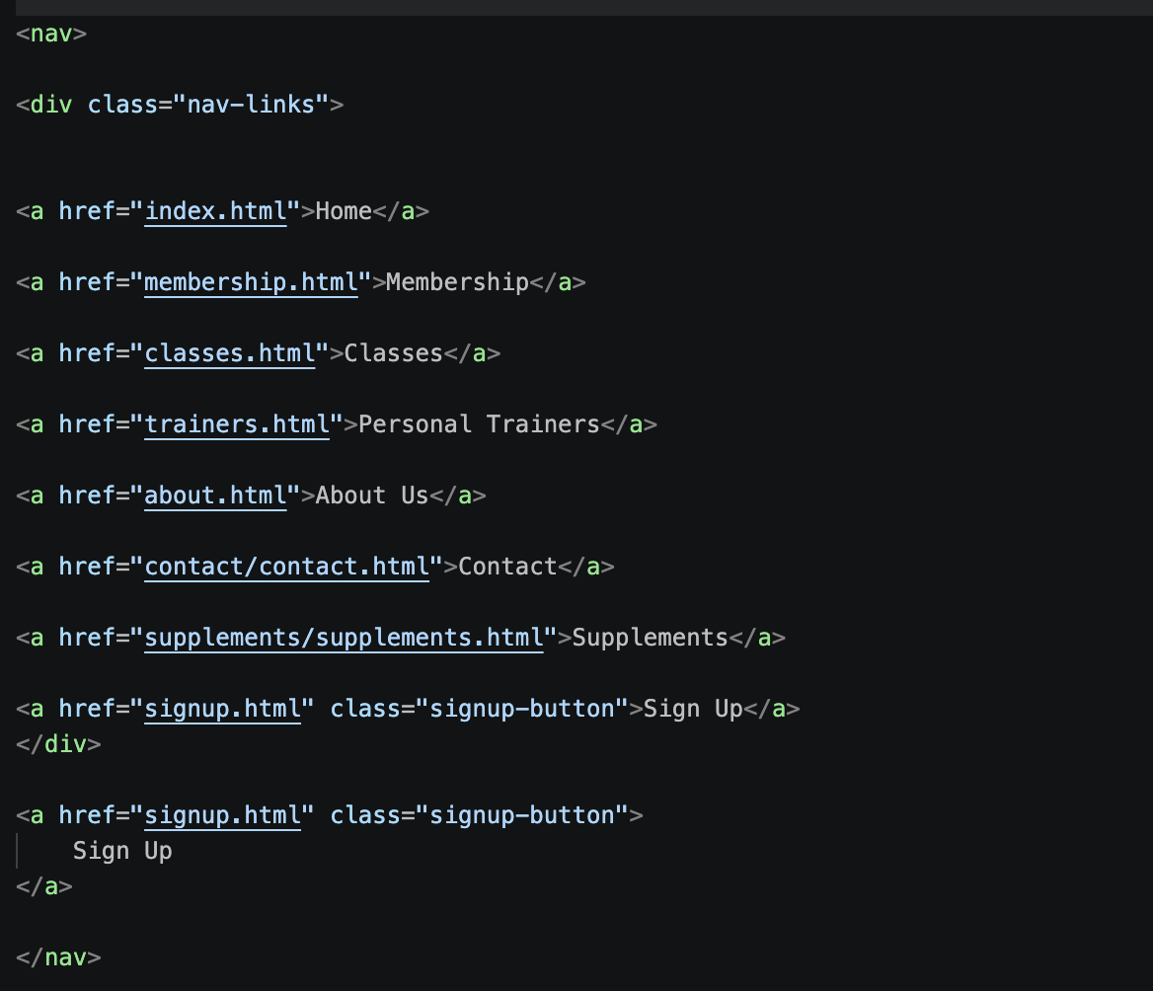
Navigation links were included on every page allowing users to quickly access different sections of the website.

CSS Implementation
A single external stylesheet was created to control the appearance of the entire website. This ensured a consistent design across every page while reducing duplicated code.
Several CSS techniques were used including:
- Flexbox
- CSS Grid
- Responsive media queries
- Hover effects
- Background images
- Border radius
- Box shadows
- Colour transitions
The homepage includes a large hero image which immediately attracts the user's attention. Semi-transparent overlays were added to improve text readability while still displaying the background images. 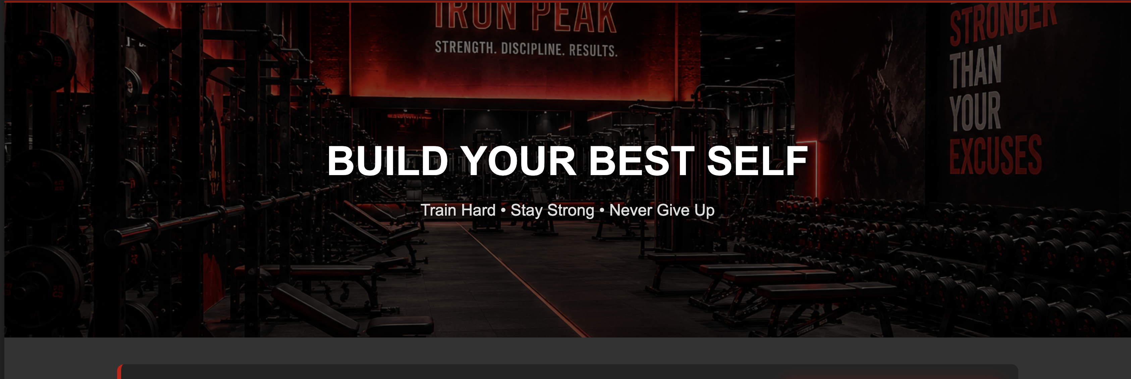
The trainer cards use consistent spacing, borders and shadows to create a professional appearance. Buttons throughout the website also share the same styling, making navigation consistent. Media queries were included to ensure the website adapts correctly for smaller devices by stacking content vertically and resizing images appropriately.

JavaScript and jQuery
JavaScript was used to improve user interaction.
One of the main JavaScript features is the homepage slideshow. Three gym images automatically rotate every few seconds using JavaScript. CSS transitions create a smooth fade effect between each image, making the homepage more visually engaging. JavaScript was also used for interactive form validation to ensure users complete required fields before submitting forms. This reduces invalid input and improves the overall user experience. jQuery was used to simplify DOM manipulation and event handling throughout the website. Using jQuery reduced the amount of code required compared to plain JavaScript while improving readability. These interactive features satisfy the coursework requirement to include JavaScript and jQuery for controlling information displayed on the webpage.

Website Features
The completed website includes several key features: the homepage introduces visitors to Iron Peak Fitness using a motivational quote, an automatic slideshow and information about the gym, the Membership page provides information about available membership plans, the Personal Trainers page introduces members to qualified trainers with profile images, descriptions and pricing for personal training sessions, the Supplements page displays products that members can purchase, the Contact page allows users to get in touch with the gym, the Sign Up page enables users to register for an account by completing a web form and each page contains navigation links allowing users to move easily around the website.

Accessibility
Accessibility was considered throughout the development process. Images include descriptive alternative text so screen readers can describe their contents. Colour contrast between the dark background and white text improves readability. Large buttons and navigation links make the website easier to use on both desktop and mobile devices. Responsive layouts ensure content remains readable regardless of screen size. Consistent navigation throughout the website also helps users quickly understand how to move between pages. These design decisions improve usability for a wider range of users and align with the coursework emphasis on accessibility.

Challenges Encountered
Several challenges were encountered during development. One challenge involved creating the homepage slideshow. Initially the images changed instantly without a smooth transition. This was solved by combining JavaScript with CSS opacity transitions, resulting in a smoother animation. Another challenge involved keeping the design consistent across every page. As more pages were added, maintaining identical headers, navigation bars and footers became difficult. This was solved by using a single external stylesheet containing shared styles. Finally, managing multiple HTML pages required careful organisation of folders and image files to ensure links worked correctly throughout the website.

Individual Contribution
My primary contribution focused on both the visual design and front-end implementation of the website.
My responsibilities included:
- Organising a WhatsApp group to structure workload
- Designing the homepage
- Creating the Personal Trainers page
- Styling the website using CSS
- Creating the JavaScript image slideshow
- Building the navigation system
- Selecting and optimising images for the homepage and Personal Trainers page
- Maintaining a consistent theme across all pages
- Testing links and page navigation
I also contributed to improving usability by ensuring the layout remained responsive across different screen sizes and by making navigation clear and consistent.

Evaluation
Overall, I believe the project successfully achieved its objectives by creating a modern, responsive website for a gym business.
The combination of semantic HTML, external CSS, JavaScript and jQuery created an interactive website that is visually appealing and easy to navigate. The use of responsive layouts ensures the website works across different devices while accessibility improvements make the site suitable for a wider audience. If I were to continue developing the website, I would add a fully functioning membership database, online booking for personal training sessions, a shopping basket for supplements, member login functionality and integration with Google Maps and social media. These features would make the website more practical for a real-world business.

